Final Project: World Sensing Music Station
a handheld instrument for turning movement and space into sound

10 + 10 scribble sketches

See next page
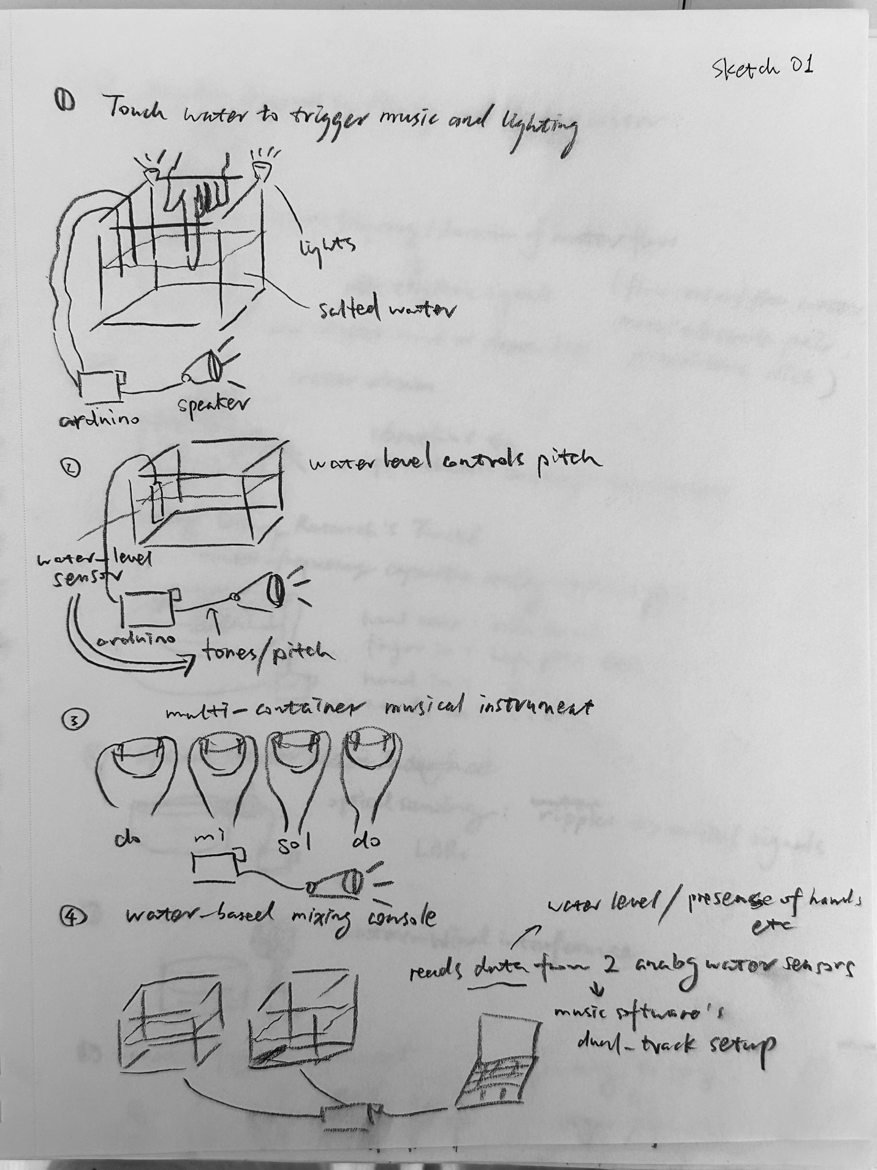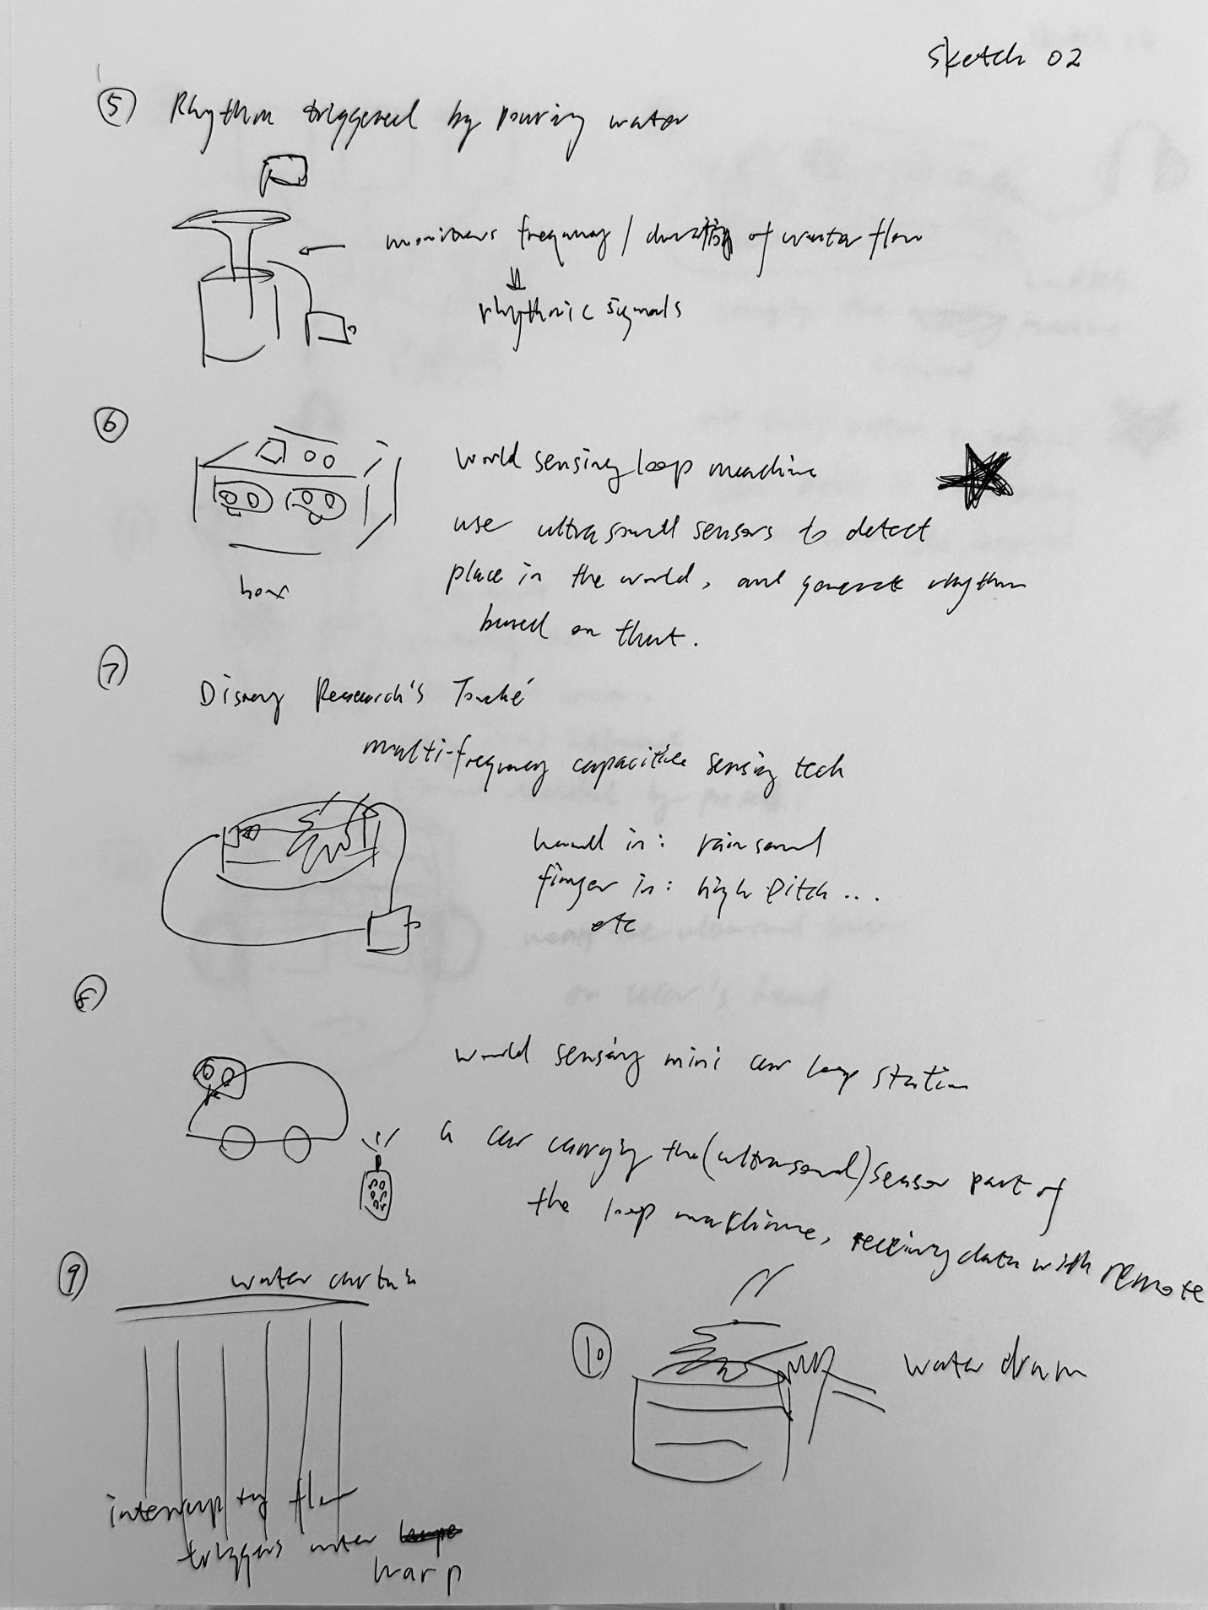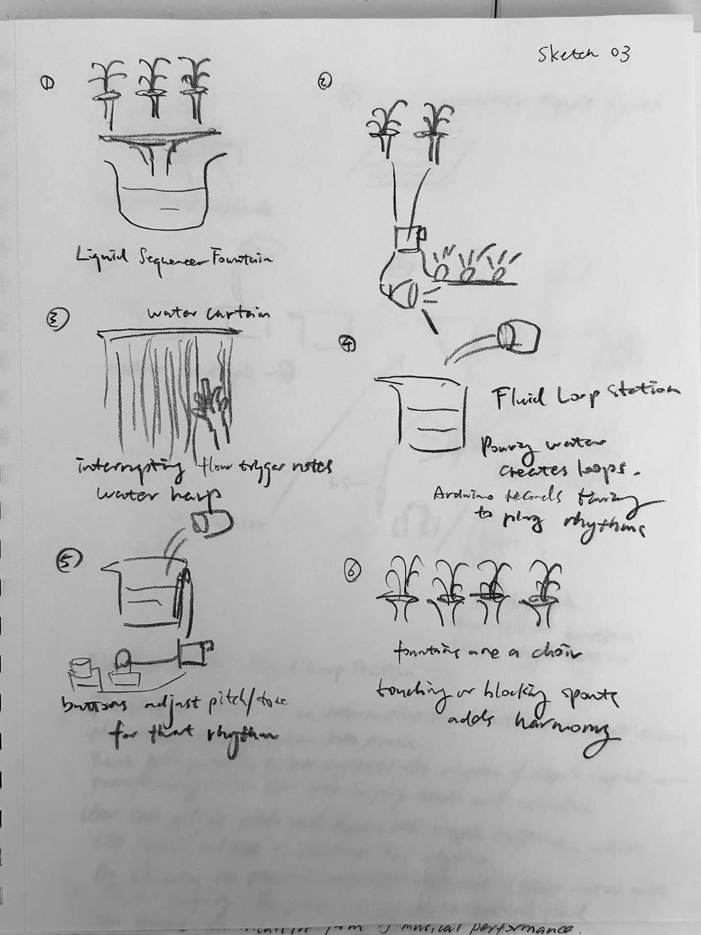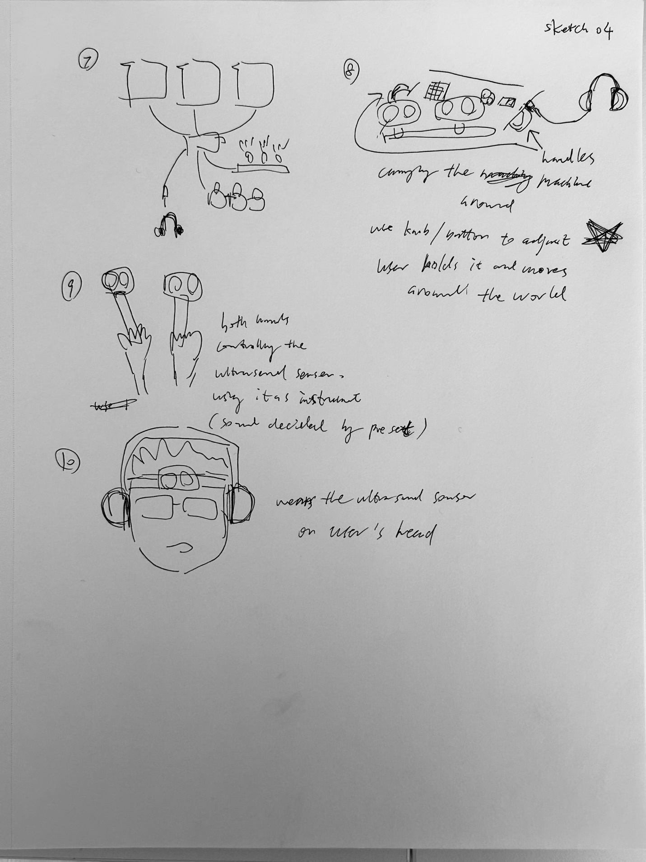

Elevator pitch

World Sensing Music Station is an interactive instrument that turns physical space into sound. Using ultrasonic sensors, it reads distance and movement in real time and maps them to rhythm, pitch, and texture. As you move through familiar routes, the system generates recurring musical loops—transforming everyday motion into a living, repeatable composition.

World Sensing Music Station is an interactive instrument that turns physical space into sound through movement. Using ultrasonic sensors, it captures distance, speed, and spatial change in real time and maps them to rhythm, pitch, and sonic texture. Beyond passive interaction, users can intentionally design their own movements—changing pace, direction, and proximity—to experiment with how space shapes music, treating their body as a controllable input within a responsive system.

World Sensing Music Station is a handheld, sensor-based instrument that turns movement through space into sound. Housed in a box with a forward-facing ultrasonic sensor, the system continuously reads distance and motion while physical knobs and buttons allow users to adjust musical parameters in real time. As users repeat familiar routes, the device naturally produces recurring rhythmic patterns, while intentional movement and manual control let them actively experiment—blending habitual motion with deliberate music-making in a single responsive system.

Identified Research Gap

Across existing research, there is extensive work on movement-based musical instruments, gesture-to-sound mapping, and context-aware music systems. However, these studies rarely address a single handheld instrument that combines everyday routine movement with intentional, real-time music creation, allowing users to both generate recurring musical patterns through habitual motion and actively shape sound using physical controls while moving. This gap motivates the design of the World Sensing Music Station.

1) “Designing Felt Experiences with Movement-Based, Wearable Musical Instruments: An Inclusive Design Approach”
Cavdir et al.

This paper studies how wearable musical instruments can be designed around bodily movement and felt experience. It shows that movement itself can be expressive and meaningful as a musical input, especially when the instrument is designed with care for accessibility and comfort. However, the work mainly focuses on performance-oriented wearables and does not address how everyday movement or repeated routines might generate musical structure over time, which helps clarify the gap my project explores.

2) “Gesture in Performance with Traditional Musical Instruments and Electronics: Gestural Mapping Strategies”
Visi et al.

This paper examines different strategies for mapping human gestures to electronic sound during performance. It highlights how mapping choices strongly affect expressiveness and usability, which informs how sensor data should be translated into music. The work assumes intentional performance contexts and does not consider how routine, non-performative movement could gradually form repeating musical patterns, pointing to a gap my prototype aims to fill.

3) “Hand Gesture Sensing with Ultrasonic Beamforming”
Iravantchi et al.

This paper presents ultrasonic sensing as a reliable way to detect hand gestures without cameras. It supports the technical feasibility of using ultrasonic sensors for real-time interaction, which is important for my project’s sensing approach. However, the paper focuses on sensing technology rather than musical interaction or long-term everyday use, leaving open how such sensing can support both routine-based behavior and active music creation.

4) “Interactive and Context-Aware Mobile Music Experiences”
Seppänen et al.

This work explores how mobile systems can adapt music based on contextual data such as movement or activity. It shows that daily life can meaningfully influence musical experiences, which aligns with my interest in routines shaping sound. At the same time, the system treats users mainly as listeners rather than performers, highlighting a gap between adaptive music systems and hands-on, movement-driven instruments.

5) “Context-Aware Mobile Music Recommendation for Daily Activities”
Wang, Rosenblum, and Wang

This paper uses sensor data to infer daily activities and recommend appropriate music. It demonstrates how routines can be detected and modeled through sensing, reinforcing the idea that everyday movement has structure. However, the system focuses on recommendation rather than creation, helping define the gap my project addresses: turning routine sensing into music generation that users can actively shape through movement and physical controls.

Together, these papers clarify a consistent gap in prior work: the lack of a portable, movement-driven instrument that merges routine-based sensing with intentional, real-time music making. The World Sensing Music Station addresses this gap by allowing users to generate recurring musical structures through everyday movement while actively shaping sound using physical controls during motion.

Storyboard
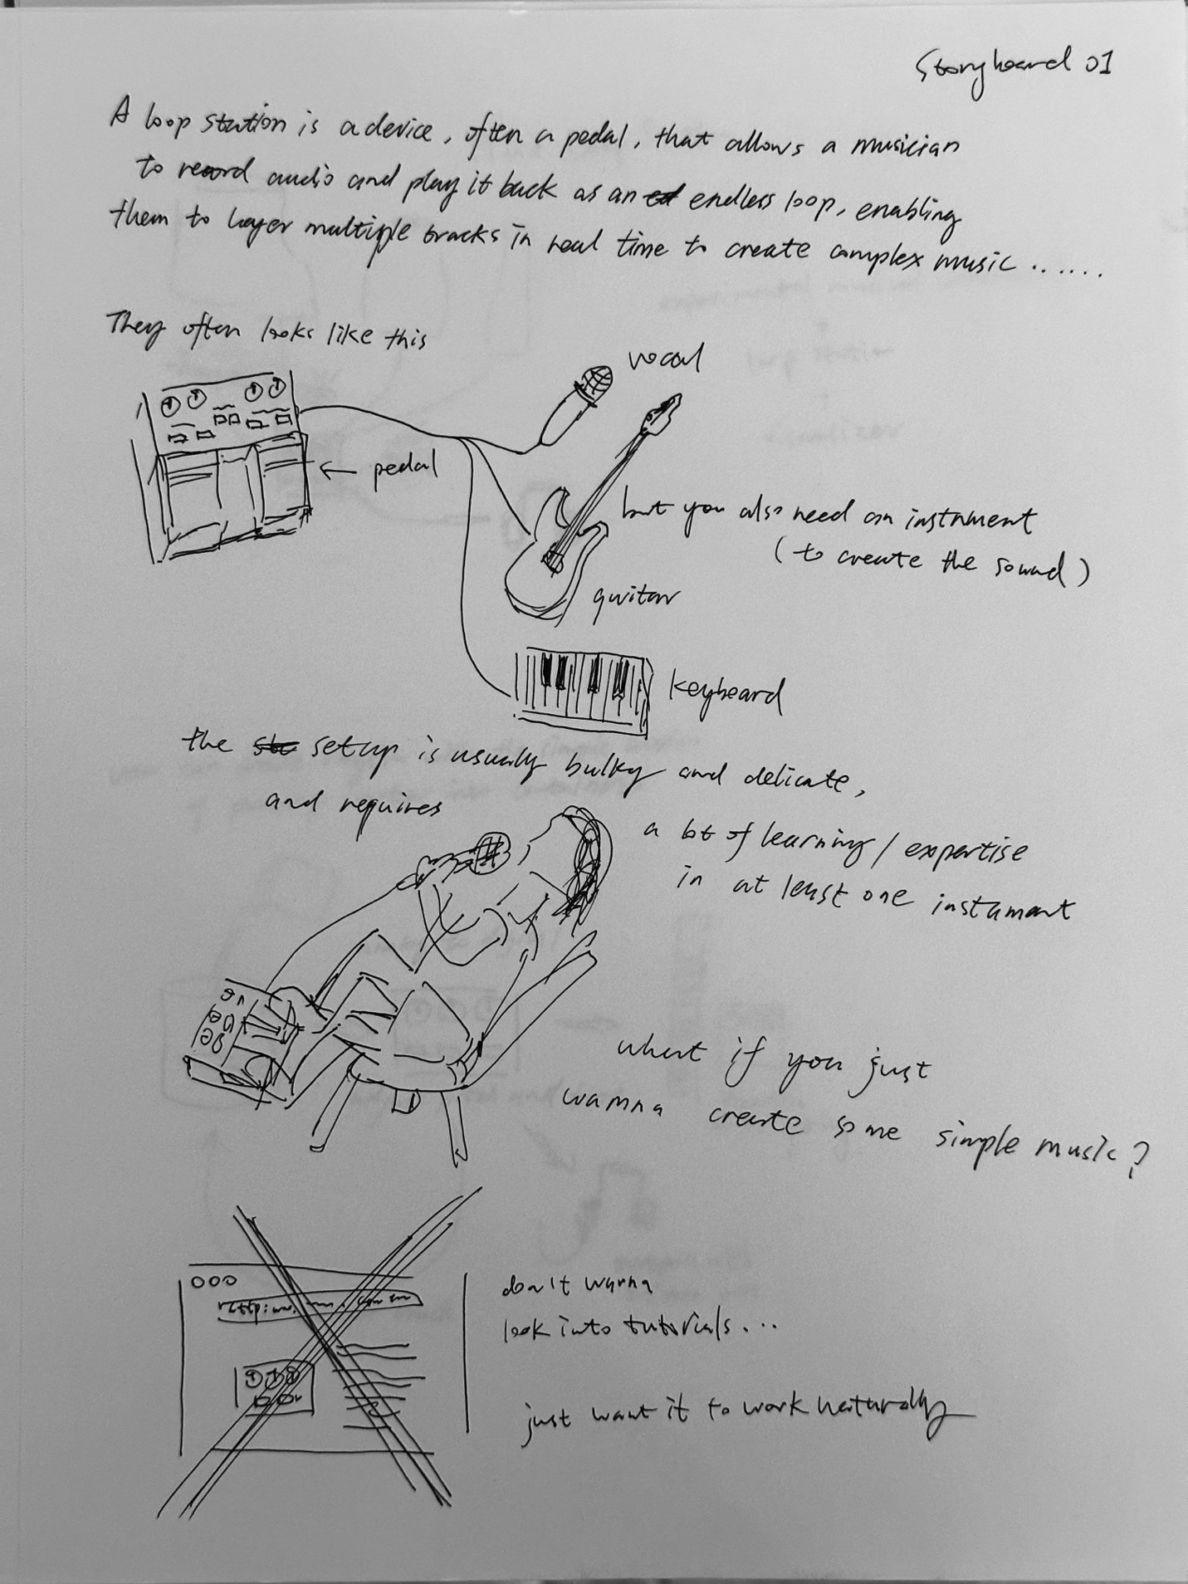
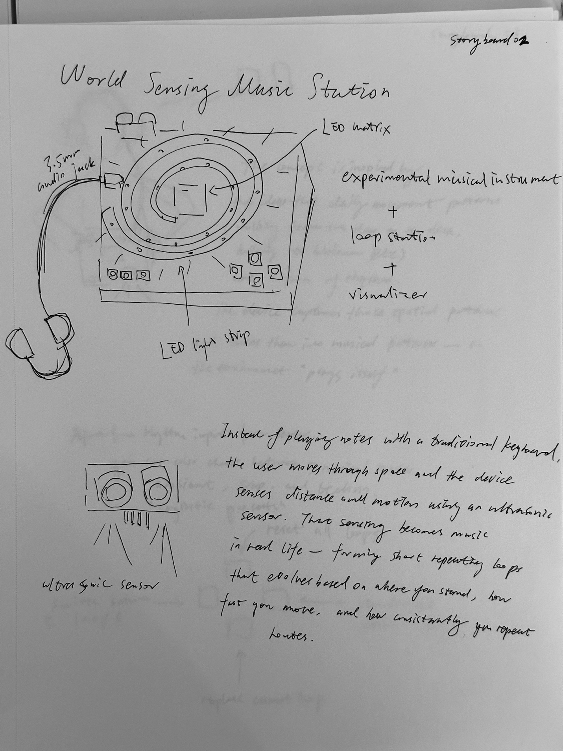
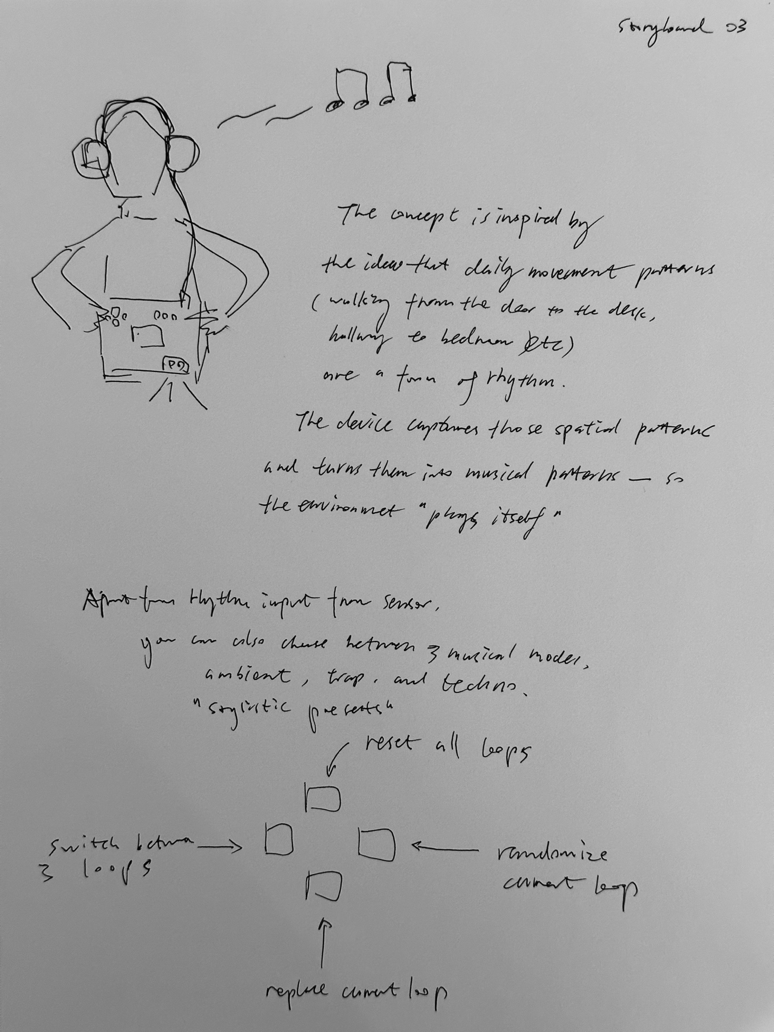

GitHub link:

https://github.com/SmartChen2005/journal/tree/main/Final%20Project

Photo of device in use

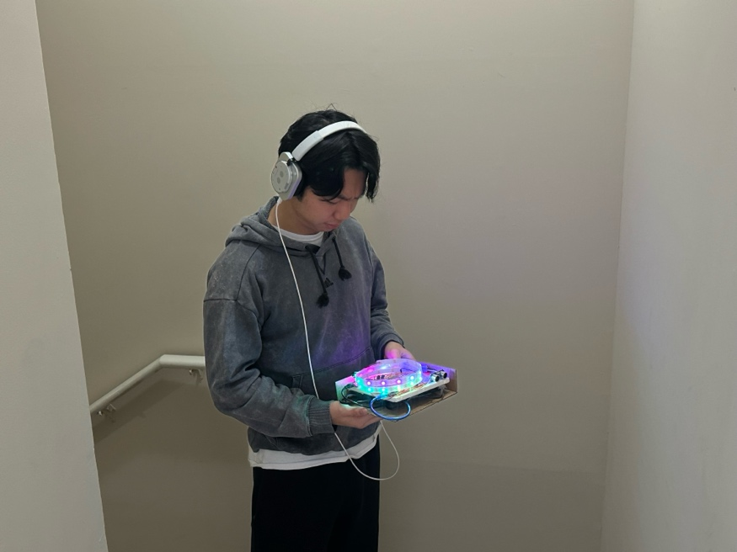

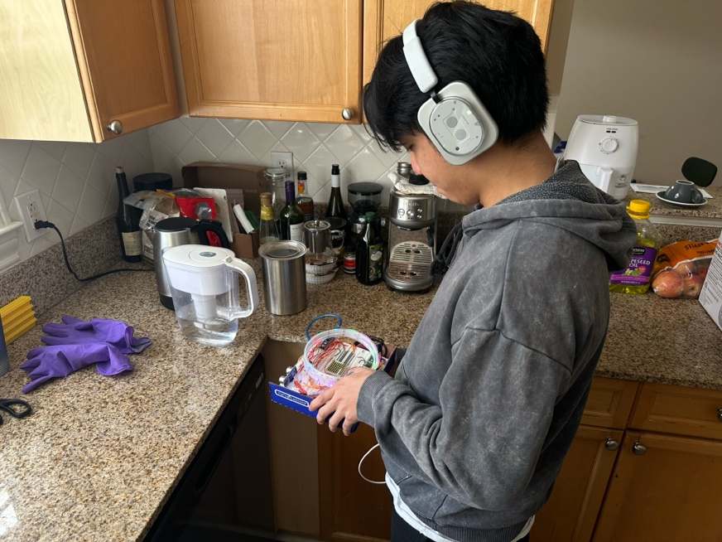
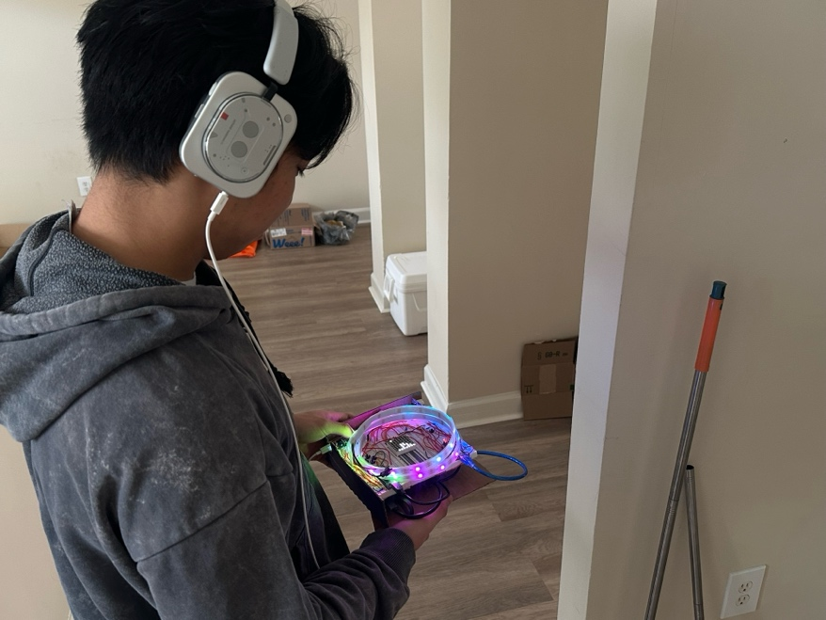

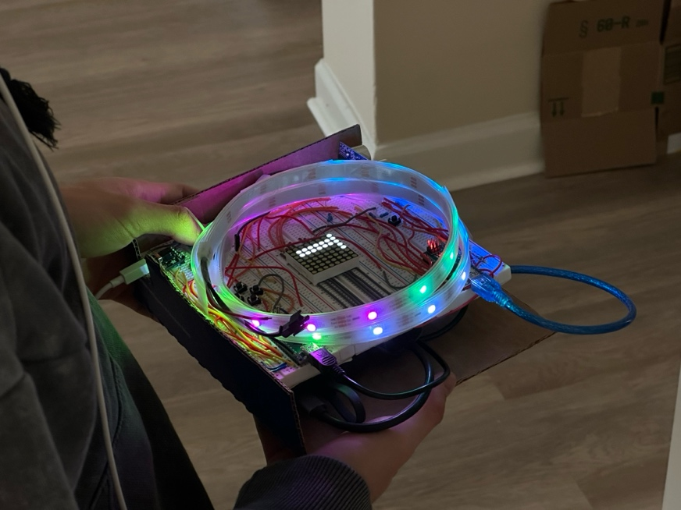

Video:
https://youtube.com/shorts/EojQMf95e6k

